  - Door Operator Information – Label Next 300
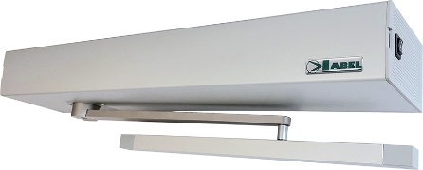
Your new door operator will look like the image above.

To ensure the maximum reliability from your system we recommended it should be serviced every 12 months.

If a maintenance agreement is already in place with us we will automatically contact you to arrange a convenient date & time for a service visit.

Opening the Door

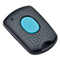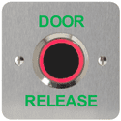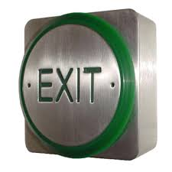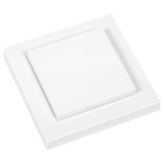

The door operator will normally have been installed with a key fob and/or push button (see sample images above).

To operate the door press the button provided and the door will operate for the time requested at installation (typically 8-15 seconds), or alternatively the system can be set so that the button opens the door on first press and closes on a further press.
You can also open the door manually if required by either pushing or pulling the door open. However, it is important that the door is not forced to close as this will damage the operator. Let the door close automatically.

It is important that the door is NOT manually locked with the key. If this is required, the operator should be switched into manual or off. Operation of the opener whilst the door is locked will damage the unit.

Key override Switch

This is normally positioned next to the door operator unless otherwise requested - it has 3 positions & the key can be removed to stop unauthorised use.
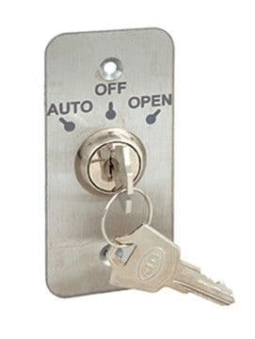

- For normal operation of the door from the key fobs and push buttons etc the Key should be set to ‘Auto’.
- When the Key is put into the ‘Open’ position the door operator will open and stay open.
- When the Key is put into the ‘Off’ position the door operator is set for manual use only.

Safety Sensors
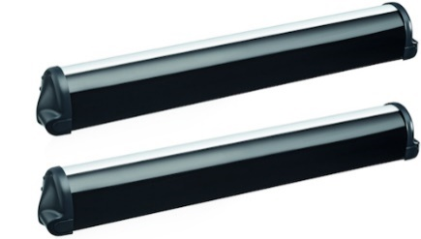
These are fitted to both sides of the door. These sensors stop the door from operating if anyone or anything is positioned in front or behind the door when it is moving. It is important that they are kept clean and not covered up otherwise the operator will no longer work, which will stop the operator from working.

FIRE ALARM TEST
If your door operator has been linked to the fire alarm system it is very important that this is tested when you test the fire alarm. The door should be tested when the fire alarm is tested to ensure it closes correctly.
- Set the mode selector to the ‘DOOR OPEN’ mode.
- When the fire alarm is put into test mode the door should close. If it does not close you should contact us ASAP.
- Once you have completed the test and you are happy the door closes when the fire alarm is activated set mode selector to ‘AUTO’.
- Test the door operator to make sure everything is working as normal again.

Trouble shooting
If you are having any difficulty in operating the door:
- Ensure the operator is switched ‘On’ and set to ‘Auto’
- Check that there is no objects which may be interfering with the range of the safety sensors or physically blocking the movement of the door
Examples: Something behind the door, door catching on the on the floor, dirty sensors, post not pushed fully through the letter box.
- Switch the door operator ‘Off’, leave for 1 minute, and then switch it back ‘ON’.
- Ensure that the batteries in the key fob or wall buttons are functioning & do not require replacing

If problems persist, please contact us using the details at the end of these instructions

Should you experience any issues or have any questions please contact us:

DH2 Solutions Ltd
Unit 25G2, Springfield Commercial Centre, Bagley Lane, Leeds, LS28 5LY
Telephone: 0113 2564572
Web: DH2Solutions.co.uk
Email: info@dh2solutions.co.uk

